Best practice reflective supervision
Family violence, sexual assault and child wellbeing
OFFICIAL

Background
This information sheet is for the family violence, sexual assault, and child wellbeing sector (the sector). It provides a practical overview of reflective supervision.
The information applies to:
- individual supervision
- group or peer supervision sessions
- policy development
- supervision training.
It aims to explain what we mean by reflective supervision within the sector. This is best read alongside the supervision definitions and functions information sheets.

Why is reflective supervision so important?
Reflective supervision is particularly important for the sector because:
- These workforces are exposed to unique psychological health, safety and wellbeing risks. We must recognise and normalise the impact on practitioners’ emotions, behaviours and reactions. Vicarious trauma and employee burnout are widespread issues.
- Practitioners work on a micro level to address structural and systemic problems. They may experience fatigue and burn out as a result.
- Systemic discrimination and racism in Australia mean extra health, safety and wellbeing impacts on First Nations practitioners and those from diverse communities. These practitioners often work with their own communities and carry a ‘cultural load’.
- Person-centred practice is dependent on the quality of relationships between practitioners and clients. This includes being able to develop rapport, trust and empathy. It includes bringing the ‘whole self’ to practice.
- It is healthy to discuss experiences and feelings related to working with risk, uncertainty, anxiety, engagement and decision-making.
- Supervisors play a crucial role in developing, sustaining and retaining the workforce. They need their own reflective supervision to model the process and grow as leaders.
The only way to prevent being affected would be to eliminate human relationships and emotions by becoming a robot. This would exclude the best of what we bring to our work – ourselves.
—Hewson and Carrol, 2016¹

Reflective supervision
Supervision creates space for reflective practice.² Reflective supervision counters privileging thinking, efficiency, logic, formal knowledge and theories over emotions and facilitates a deeper examination of the work. In a trusting relationship, supervision focuses on being proactive in practice and decision-making, instead of reactive. Practitioners may not be aware of their feelings and subsequent reactions. Reflective questioning can ensure we recognise and process them.³
A focus on managing ‘the doing’ rather than on developing ‘the feeling’ and ‘thinking’ aspects significantly contributes to practitioners feeling unsupported by their supervisors.
—Gibbs, Dwyer and Vivekanandra, 2014⁴
In one-to-one reflective supervision, the supervisee leads the reflective supervision session. The supervisor suggests areas to explore. They assist the supervisee to find their own wisdom, rather than giving advice or direction. To encourage deep reflection the supervisor notices, challenges and invites the supervisee to be mindful of their actions and assumptions in a way that is non-judgemental, positive and hopeful.⁵
If supervisors do not prioritise supervision, neither will staff.
—Jacky Tucker, State-wide RAMP Coordinator, Safe & Equal, 2023
Regular reflective supervision should be prioritised within organisations.⁶ Time is a precious commodity in fast-paced, busy organisations, which is at odds with the slow, thoughtful space needed for reflective supervision. To engage in deep reflection, supervision needs to occur in a private and suitable location. Supervisees must feel they have the time to explore subjects and feelings uninterrupted and be truly present. (Some supervisors set aside two hours for this.)
During peer or group supervision, there needs to be a high level of psychological safety for deep critical and process reflection. For this reason, reflective practice often works best in a closed group setting. This provides the group with time and regular contact to build familiarity and trust.

What is reflection?
In its simplest form, reflection is a ‘state of mind’,⁷ rather than a technique. It prompts us to pause and notice, and then consider the meaning of what we noticed.⁸ It is a continuous, cyclical process which contributes to self-awareness and professional learning (see Figure 1 below). Reflection encourages staff to consider their impact on others, including clients and colleagues. It assists staff to monitor the wellbeing of others and encourages organisational and collective care of the workforce. It is a bridge between theory and practice and improves decision-making. Problem solving however is not the primary focus, learning is.⁹
Reflection features:
- active listening, sitting with silence and the discomfort of not always knowing
- a stance of curiosity
- open questions to make sense of situations and to support knowledge for decision-making
- empathy and non-judgement to work through complex issues, emotions and reactions in a safe-enough space
- vulnerability, allowing participants to ease the need to always appear self-reliant and strong
- a critical approach and ‘sitting outside’ our personal experience to notice how the system might be experienced by others.

Figure 1: KOLB reflective learning cycle¹⁰
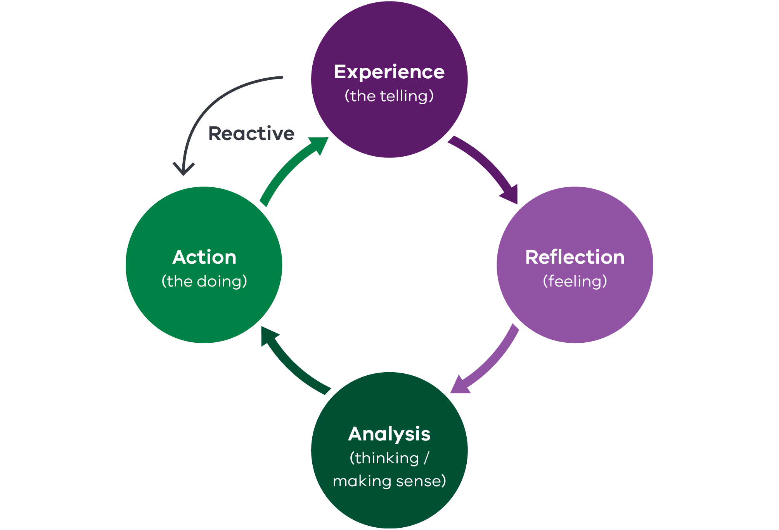
This reflective learning cycle provides the ‘how’ of reflective supervision. The idea is to regularly reflect on all four learning processes (experience, reflection, analysis and action), moving from surface to depth and shifting between them, as required.¹¹ It assists supervisees and supervisors to unpack an experience and better understand it. The goal is to be less reactive, learn from reflection and improve decision making. The model can be used to process various experiences. These might include conflict with other professionals, case practice with clients and the dynamics experienced in the supervisory relationship.

Questions that accompany the learning cycle processes

Experience questions
- Tell me about the case.
- What happened during the contact?
- What was the purpose of the contact?
- What do we know about the client(s) background, their strengths and supports available?
- What happened when you spoke with (family member/other professional)?
- How would you describe the client’s demeanour?
- What did you notice about yourself during the contact?
- What have other professionals said about the client(s)?

Reflection questions
- What were your feelings towards the client(s) during the contact?
- How would you describe your relationship with the client(s)?
- What is the client’s relationship like with their family, friends and other services?
- Does the client remind you of anybody?
- Describe any differences between this contact and previous contact.
- How do you think the client is feeling at the moment? What is this based on?
- How do you feel after the contact?
- What biases or assumptions about the situation or client(s) might have influenced you?

Action questions
- Given our reflection, what do you think we need to do and why?
- What other options are there?
- What does the client(s) want?
- What do you want to achieve with the client(s)?
- What might the client(s) think about your role and what do they need from you?
- What is urgent versus desirable?
- What support or information do you need to make the next step?
- What information do you need to share with other professionals?
- How do you see your role going forward?
- How do you plan to use your positional power going forward?
- How can I support you?

Analysis questions
- How did you make sense of what the client(s) told you or any changes you have noticed?
- What are the client’s strengths and what resources can they use?
- What are the challenges and risks?
- Did the contact confirm or challenge your previous thoughts about the client(s)’ situation?
- What evidence is there to support this?
- Is there any research that might assist us to think about the implications of the information we have?
- What information is missing?
- What professional development or research do you think might help you with this case?

Four levels of reflection
It can be helpful to consider the following four levels of reflection:¹²
- Technical reflection compares performance with knowledge of what should have happened. It is useful in addressing accountability and compliance issues.
- Practical reflection relates to the supervisees’ self-evaluation, insight and learning. Reflection on action (after the experience) enhances a practitioner’s ability to do reflection in action. This involves being able to use experience and intuition to respond in the moment.
- Critical reflection acknowledges that understanding is never complete. Understanding is continuously evolving and is influenced by the social and political context. It is an important process to uncover and explore power, assumptions, biases and values at an individual and organisational level. This reflection informs and improves practice, as well as raising the moral and ethical aspects of practice. It is crucial for embedding intersectionality.
- Process reflection explores conscious, unconscious and intuitive aspects of practice even when it is difficult or uncomfortable. It delves into the psychological aspects of the work, exploring client and supervisee histories, motivations, behaviours and reactions. This process can use trauma, attachment and systems theories to explore the complex dynamics and patterns of interacting.
All four levels of reflection are important, depending on the context and type of supervision, such as managerial or clinical supervision. For more on these, refer to the supervision definitions information sheet.

Reflexivity
The sector often uses the term reflexivity, which is like reflection. Simply, reflection leads to insight about something, whereas reflexivity involves finding strategies to question our ‘attitudes, values, assumptions, prejudices, and habitual actions’. Reflexivity helps us understand how we contribute to the dynamic with others.¹³
Reflexivity extends the reflective learning cycle. It is a deeper process, like critical and process reflection. Reflexivity can prevent generalising client stories and enables supervisees to see what is unique about every case. It involves clarity and awareness of the way practitioners are experienced and perceived by others.
We make sense of situations through stories. Therefore, strategies to enhance reflexivity include journalling about the work and regularly doing through-the-mirror writing.¹⁴ This is where practitioners use imaginative stories, drawn from experience, to explore the problems, anguish and the joys of practice. These can be shared and discussed with colleagues and supervisors to increase learning about the self.
To be reflexive is to examine … how we – seemingly unwittingly – are involved in creating social or professional structures counter to our own values (destructive of diversity, and institutionalising power imbalance, for example). It is becoming aware of the limits of our knowledge, of how our own behaviour plays into organisational practices and why such practices might marginalise groups or exclude individuals.
—Bolton, 2009

Reflection readiness
Reflection is not always a positive and desirable process and both supervisees and supervisors need to be ready to move into reflective practice.¹⁵ This is because exploring the more challenging and difficult aspects of practice requires motivation, energy and openness and we can become self-protective. Supervisors need an empathic, non-judgemental approach and to gauge the supervisee’s willingness to explore deep reflection.
Sometimes, there are tensions. Organisations must balance wanting a healthy learning culture that embraces reflective practice and feedback/feedforward, with practitioner reflection readiness.
It can be difficult to embed reflective practice at first because it involves time and conscious effort but with persistence it becomes natural and habitual.
—Hewson and Carroll, 2016

Safety
It is useful to think of safety along a continuum rather than a binary model of feeling safe or unsafe. Practitioners sometimes point to lack of safety for not engaging in supervision or challenging conversations. This may be more about feeling uncomfortable, which is necessary for growth and learning. The concept of being ‘safe enough’ to be vulnerable and willing to explore the impacts of the work is more useful than using the language of ‘being unsafe’.¹⁶ Yet, if after their own reflection a supervisee genuinely feels there is a lack of safety in their supervisory relationship, organisations need to provide a system to hear and review this.
When thinking about safety, it is important to also ensure that organisations and supervisors create an environment that is culturally responsive and safe for Aboriginal and Torres Strait Islander supervisees and people from other diverse communities.

Trauma and violence-informed approach
This information sheet is supported by an agreed set of trauma informed principles based on the Blue Knot Foundation model. It is recognised that other trauma informed models are equally useful, such as the Sanctuary Model.¹⁷
In the family violence context, it can be useful to adopt a trauma and violence informed approach, which expands the concept to ‘account for the intersecting impacts of systemic and interpersonal violence and structural inequities on a person’s life’.¹⁸
Trauma and violence-informed principles can be useful in underpinning reflective supervision.¹⁹ Especially since many supervisees and supervisors have their own lived experience of trauma, or family or sexual violence and the impacts of inequality, discrimination and marginalisation. Talking with practitioners who have not experienced trauma and who may benefit from privilege about the principles and impacts of trauma and violence is equally crucial.
A trauma and violence-informed approach also assists supervisors and supervisees to have explicit conversations about the power dynamics that may impact their relationship.
This approach aligns with the Framework for trauma-informed practice,²⁰ which promotes reflective supervision as a key strategy in creating trauma-informed workplaces.
Table 1: Trauma informed principles in practice adapted from the Blue Knot Practice Guidelines²¹
Principle | What this looks like | Reflective questions
Safety | Foster physical, psychological, identity and cultural safety in all interactions. | How does your service create safety for supervisees and supervisors?
Trust | Invest in inclusive relationships that focus on mutual respect, dignity and transparent, unbiased communication. | Does your service demonstrate trauma sensitivity at all levels of contact?  How does your service convey reliability to the workforce and clients?
Choice | Provide freedom for supervisees and supervisors to align their approaches with their values and ethics. | How do supervisors embed discussions about values and ethics during supervision?  How does supervision provide choice for your supervisees (and in turn clients) where it is available and appropriate? In what ways?
Collaboration | Share power and work in solidarity to support sustainability at a team, organisation, funding body and sector level. | How does your supervision style develop a sense of ‘doing with’ rather than ‘doing to’?
Empowerment | Develop individual and collective strengths by acknowledging each other’s contributions and feedback or feedforward for continuous learning and reflection. | Is empowering supervisees and clients an ongoing goal of supervision and your service?  How is this goal enabled by supervision, service systems, programs and processes?
Respect for inclusion and diversity | Develop an awareness that attitudes, systems and structures can interact to create inequality and exclusion. Respect diversity that includes intersecting social characteristics such as but not limited to cultural background, Aboriginality, sexual orientation, gender, gender identity, age, mental health, socioeconomic status, religion and disability. | How does supervision and your service convey and enact respect for workforce and client diversity in all its forms?  In what ways?  How does supervision and your organisation promote cultural safety?

Endnotes
D Hewson and M Carroll, Reflective Practice in Supervision, MoshPit Publishing, Hazelbrook, NSW, 2016.
2 Hewson and Carroll, Reflective Practice in Supervision.
3 Department of Human Services, Leading practice: a resource guide for child protection leaders, 2nd edn, State of Victoria, 2014, accessed 27 February 2023.
4 Department of Human Services, Leading practice: a resource guide for child protection leaders.
5 Hewson and Carroll, Reflective Practice in Supervision.
6 Supervision frequency will be included in the guidelines as a recommended standard.
7 G Bolton, ‘Reflective practice: an introduction’, in G Bolton and R Delderfield (eds), Reflective practice in writing for professional development, 2nd edn, Sage, London, 2009.
8 Hewson and Carroll, Reflective Practice in Supervision.
9 Hewson and Carroll, Reflective Practice in Supervision.
10 DA Kolb, Experiential learning: experience as the source of learning and development, Prentice Hall, Englewood Cliffs, NJ, 1984.
11 Department of Human Services, Leading practice: a resource guide for child protection leaders.
2 G Ruch, ‘Reflective practice in contemporary child-care social work: the role of containment’, The British Journal of Social Work, 2007, 37(4): 659-680, doi:10.1093/bjsw/bch277.
3 Bolton, ‘Reflective practice: an introduction’.
4 Bolton, ‘Reflective practice: an introduction’.
5 Hewson and Carroll, Reflective Practice in Supervision.
6 V Reynolds and M McQuaid, ‘Do you have a culture of collective accountability?’, Making Positive Psychology Work podcast, 2021.
17 Sanctuary Institute, Sanctuary Model, Sanctuary Institute website, 2023, accessed 17 August 2023.
18 Varcoe CM, Wathen CN, Ford-Gilboe M, Smye V and Browne, VEGA briefing note on trauma- and violence-informed care, VEGA Project and PreVail Research Network, Ottawa, 2016 p. 1, in Family Safety Victoria, MARAM practice guides: Foundation knowledge guide, Victoria Government website, p. 43.
9 Blue Knot, Trauma-informed services, Blue Knot website, 2019, accessed 1 March 2023.
20 Department of Families, Fairness and Housing (DFFH), Framework for trauma-informed practice, DFFH website, 2022, accessed 27 February 2023.
21 Blue Knot, Practice Guidelines, Blue Knot website, 2012, accessed 20 July 2023

To receive this document in another format email the Centre for Workforce Excellence <cwe@dffh.vic.gov.au>.
Authorised and published by the Victorian Government, 1 Treasury Place, Melbourne.
© State of Victoria, Australia, Department of Families, Fairness and Housing, July 2023.
With the exception of any images, photographs or branding (including, but not limited to the Victorian Coat of Arms, the Victorian Government logo or the Department of Families, Fairness and Housing logo), this work, Best practice reflective supervision, is licensed under a Creative Commons Attribution 4.0 licence.
The terms and conditions of this licence, including disclaimer of warranties and limitation of liability are available at Creative Commons Attribution 4.0 International Public License <https://creativecommons.org/licenses/by/4.0/>
You are free to re-use the work under that licence, on the condition that you credit the State of Victoria, Australia (Department of Families, Fairness and Housing) as the author, indicate if any changes have been made to the work and comply with the other licence terms.
ISBN 978-1-76130-141-4 (online/PDF/Word)
Available at family violence sexual assault and child wellbeing best-practice supervision <https://www.vic.gov.au/family-violence-sexual-assault-and-child-wellbeing-best-practice-supervision>
(2305476)

